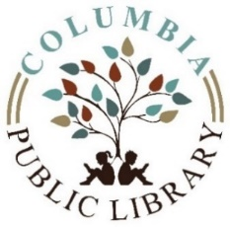
MEETING AGENDA
Columbia Public Library Board of Trustees
October 13, 2020

Citizens will be granted a 15-minute period to appear and express their views before the Columbia Public Board of Trustees at every open meeting. Each individual speaker will be limited to 3 minutes, for a total of 15 minutes per meeting. No immediate response will be given by the Library Board or Library Staff members.

- Call to order
- Approval of Minutes
- Public Comment
- Treasurer’s Report
- Approval Current Bills
- Correspondence
- Library Report
- Old Business
- New Business
  - COVID-19 Updates
  - Action Item: Seating in Library
  - Action Item: Basement Use
  - Action Item: Election Day Closure
  - Action Item: Digital Library Card Policy
  - Crystal Snyder Report
  - Action Item: Drive Thru Trunk or Treat
  - Action Item: Fall Masquerade at YMCA
  - Action Item: Santa’s Visit
- Board Orientation
  - Per Capita Grant requirements. Overview of Serving Our Public 4.0 Standards for Illinois Public Libraries.
- Adjournment
Next meeting: Tuesday, November 10, 2020

The business of the board is conducted in compliance with the Open Meetings Act, ILCS 5/120. Executive Session may be entered at any time for discussion on certain items as allowed by the Open Meetings Act; all final actions take place during open session. Final vote or action may be taken at the meeting on any agenda item subject matter listed above, unless the agenda line item specifically states otherwise.

