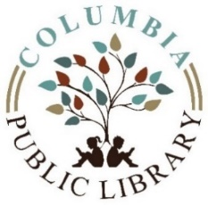
MEETING AGENDA
Columbia Public Library Board of Trustees
November 6, 2020

Citizens will be granted a 15-minute period to appear and express their views before the Columbia Public Board of Trustees at every open meeting. Each individual speaker will be limited to 3 minutes, for a total of 15 minutes per meeting. No immediate response will be given by the Library Board or Library Staff members.

- Call to order
- Approval of Minutes
- Public Comment
- Treasurer’s Report
- Approval Current Bills
- Correspondence
- Library Report
- Old Business
- New Business
  - COVID-19 Updates
  - HVAC Repair
  - Action Item: AARP Tax Service
  - Action Item: Restore Illinois Mitigation
  - Action Item: Gingerbread House Program Fee
  - Calendar Year 2021 Holiday Closures
  - Calendar Year 2021 Regular Board Meeting Dates
  - Staff training
- Board Orientation
  - Per Capita Grant requirements. Overview of Serving Our Public 4.0 Standards for Illinois Public Libraries.
- Adjournment
Next meeting: Tuesday, December 8, 2020

The business of the board is conducted in compliance with the Open Meetings Act, ILCS 5/120. Executive Session may be entered at any time for discussion on certain items as allowed by the Open Meetings Act; all final actions take place during open session. Final vote or action may be taken at the meeting on any agenda item subject matter listed above, unless the agenda line item specifically states otherwise.

