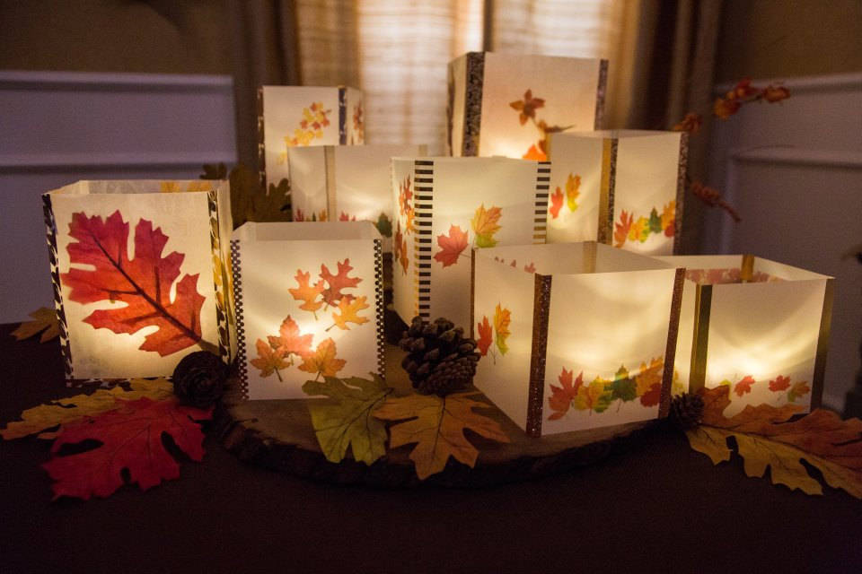
Diy autumn leaf Lantern
Instructions from Hallmark Channel Website:
Materials: • Wax Paper • Scissors • pencil and eraser • Iron • Ironing board or flat work space to iron on • Ironing Cloth (Optional) • Leaves; real or artificial • Decorative washi tape • Votive candles, battery operated

Make It!
- Fold wax paper in half and cut out into 8x8” squares or to whatever size you desire your lantern to be.
- Take your leaves and set them inside the folded wax paper.
- Cover with the ironing cloth and gently iron over the cloth until the wax paper seals together. Remove cloth. You now have one of the sides completed for your lantern.
- Repeat steps 1-3 until you have created four wax paper sides for your lantern.
- Using your washi tape, tape together the sides of your wax paper to create a cube shape. It’s okay for the washi tape to be showing – this is why we shows decorative fall colors!
- Turn on your votive candles and place inside the lanterns and decorate as desired.
Reference: Hallmark Channel. (2020). How to – DIY Autumn Leaf Lanterns (Blog Post). Retrieved from https://www.hallmarkchannel.com/home-and-family/how-to/diy-autumn-leaf-lanterns

