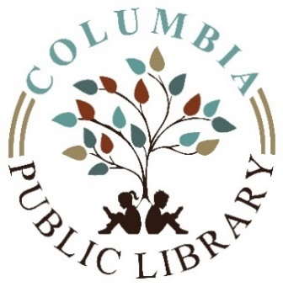
Columbia Public Library
Special Board Meeting Public Notice
Thursday November 19, 2020
Meeting will take place in
Columbia Library Basement Meeting Room

- Call to order
- Declare a quorum
- Purpose of meeting –
      - Discuss and vote on future operations due to new mitigation.
- Public comments
- Adjourn

