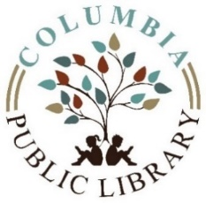

Columbia Public Library
Special Board Meeting Public Notice
Saturday, June 12, 2021 at 2:00 pm
Meeting will take place in
Library Directors Office

- Call to order
- Declare a quorum
- Purpose of meeting-
    - Discuss and vote on future operations due to
State moving into phase 5
- Public comments
- Adjourn

