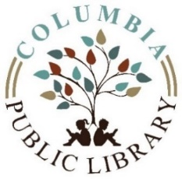
MEETING AGENDA
Columbia Public Library Board of Trustees
August 9, 2022

Citizens will be granted a 15-minute period to appear and express their views before the Columbia Public Board of Trustees at every open meeting. Each individual speaker will be limited to 3 minutes, for a total of 15 minutes per meeting. No immediate response will be given by the Library Board or Library Staff members.

- Call to order
- Approval of Minutes
- Public Comment
- Treasurer’s Report
- Approval Current Bills
- Correspondence
- Library Report
- Old Business
- New Business
  - Discussion and vote Bylaw Policy
  - Discussion and vote Non-Resident Student Card
  - Discussion and vote Non-Resident Student Card Policy
- Board Orientation
- Adjournment
Next meeting: Tuesday, September 13, 2022

The business of the board is conducted in compliance with the Open Meetings Act, ILCS 5/120. Executive Session may be entered at any time for discussion on certain items as allowed by the Open Meetings Act; all final actions take place during open session. Final vote or action may be taken at the meeting on any agenda item subject matter listed above, unless the agenda line item specifically states otherwise.

