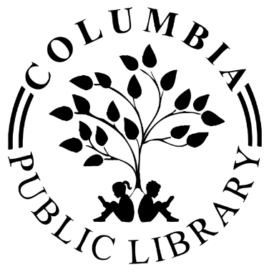

**Columbia Public Library**

**Special Board Meeting Public Notice**

**Tuesday, January 28th, 2025 - 7:00 p.m.**

**Columbia Library, 106 N. Metter Avenue**

1. Call meeting to order
2. Roll Call
3. Public Input
4. Closed Session:
5. 5 ILCS 120/2(c)(1) Appointment, Employment, Compensation, Discipline, Performance, or Dismissal of Specific Employees of the Public Body.
6. Call meeting into regular session
7. Adjournment